Project Name: Hospital Management

Members:

Ahmed, Quazi Nafis : 14-27012-2

Kamruzzaman, Md. : 14-27018-2

Asaduzzaman, Md. : 14-28097-3

Islam, Tanvir Ul : 14-27029-2

Class Diagram :

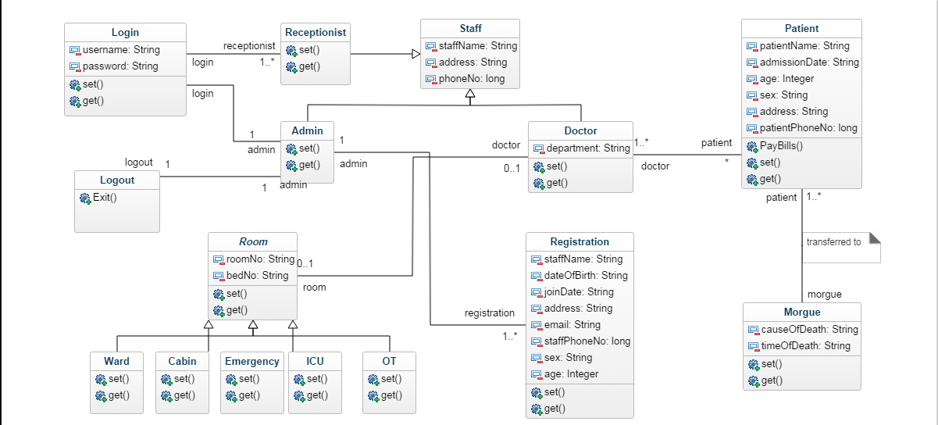

ER Diagram :

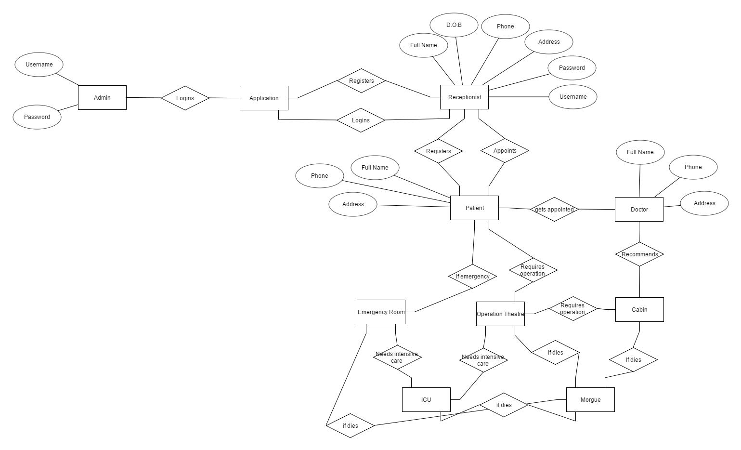

Activity Diagram :

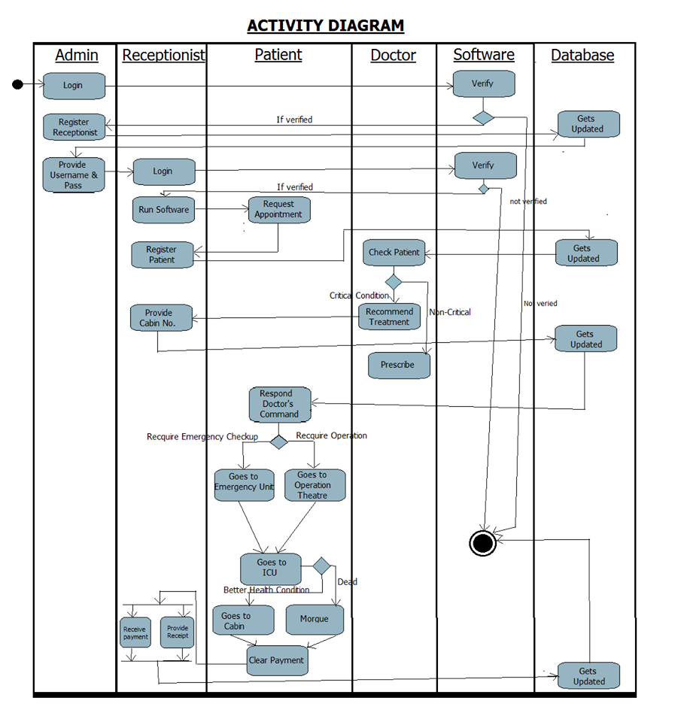

Use Case Diagram :

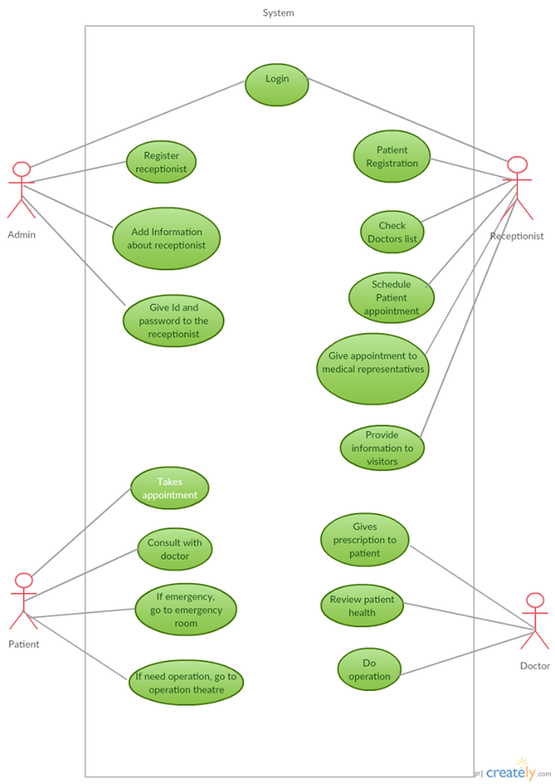

Project Layout :

